**A REPORT ON**

**MANAGING WASTE FOOD**

SUBMITTED TO THE SAVITRIBAI PHULE PUNE UNIVERSITY, PUNE

IN THE PARTIAL FULFILLMENT OF THE REQUIREMENT

***OF***

**PROJECT BASED LEARNING (SECOND YEAR ENGINEERING)**

SUBMITTED BY : GROUP 8

GROUP MEMBERS:

1)REETESH TOMAR

2)SHUBHAM CHAUBEY

3)RAJESH KUMAR

4)RAVINDRA SINGH

5)BANTI KUMAR



## DEPARTMENT OF ENTC

## ARMY INSTITUTE OF TECHNOLOGY

DIGHI HILLS, ALANDI ROAD, PUNE 411015

## SAVITRIBAI PHULE PUNE UNIVERSITY

## 2020 -2021



**CERTIFICATE**

This is to certify that the project report entitles

**“MANAGING WASTE FOOD”**

is a bonafide student of this institute and the work has been carried out by him under the supervision of **Prof. JB JAWALE**  and it is approved for the partial fulfillment of the requirement of , First year course on Project Based learning of Savitribai Phule Pune University.

**(Prof. JB JAWALE)**               **(Prof. )  Dr. G R Patil**

Guide                                           Head,

Department of ENTC                                                                Department of ENTC

**((Dr. B.P.Patil)**

Principal,

Army Institute of Technology, Dighi, Pune – 411015

Place: Pune Date: 20 JUNE 2021 **ACKNOWLEDGEMENT**

The success and final outcome of this project required a lot of guidance and assistance from many people and I am extremely privileged to have got this all along the completion of my project. All that I have done is only due to such supervision and assistance and I would not forget to thank them.

I respect and thank Brig Abhay A Bhat, Dr. B.P.Patil and Prof. JB Jawale sir, for giving this opportunity to do the project and providing us all support and guidance which made me complete the project duly. I am extremely thankful to him for providing such a nice support and guidance, although he had busy schedule managing the corporate affairs. We are thankful to our guides, for developing such a good thing of saving food and using the wasted food in other development and various other things which helped me a lot. I support and appreciate this initiative step from our university and I am thankful to University for introducing this new skill development project-based learning subject in our semester we learned a lot in this period of development of our application. I am thankful to the "Open source software Club" of our institute. "OSS Club" members taught us android development and web development. They guided us whole year.

**ABSTRACT**

Most people don't realize how much food they throw away every day — from uneaten leftovers to spoiled produce. About 94 percent of the food we throw away ends up in landfills or combustion facilities. In 2017, we disposed 38.1 million tons of food waste. By managing food sustainably and reducing waste, we can help businesses and consumers save money, provide a bridge in our communities for those who do not have enough to eat, and conserve resources for future generations.

Food waste can occur due to various reasons which can occur at various stages of food

production. Reducing these wastes can significantly affect the economy of countries

especially developing ones. This can bring down the prices of food, reduce the

environmental impact and decrease the losses on food processing.

Reduce waste by using Biodegradable Packaging:

We all purchase our food items at the local market or a grocery store. But most of the

time we do not carry a bag to bring back the food items in. At those scenarios, if a

biodegradable bag is used instead of a regular plastic bag, it can reduce the amount of

waste formed significantly. Consumers can be encouraged to always carry a jute bag to

put their items in when they go to the market. This further reduces the amount of

wastage caused due to packaging, also it provides a reasonable boost to the local jute

textiles.

So, here is how we are connecting with people and awaking the people about this wastage

So by the time they will get to know that what they are doing then it is best for all.

**TABLE OF CONTENTS**

LIST OF ABBREVATIONS i

LIST OF FIGURES ii

LIST OF TABLES iii

# CHAPTER TITLE PAGE NO.

|  |  |  |  |  |  |  |  |
| --- | --- | --- | --- | --- | --- | --- | --- |
| **Sr.No.** | | | | **Title of Chapter** | | | **Page No.** |
| **01** | | | | **Introduction** | | | **10** |
|  | 1.1 | | | Overview | | | 10 |
|  | 1.2 | | | Motivation | | | 11 |
|  | 1.3 | | | Problem Definition and Objectives | | | 12 |
|  | 1.4 | | | Project Scope & Limitations | | | 13 |
|  | 1.5 | | | Methodologies of Problem solving | | | 13 |
| **02** | | | | Literature Survey | | | **14** |
| **03** | | | | Software Requirements Specification | | | **16** |
|  | | 3.1 | | Assumptions and Dependencies | | | 16 |
|  | | 3.2 | | Functional Requirements | | | 16 |
|  | |  | | 3.2.1 | | Magnetometer | 16 |
|  | |  | | 3.2.2 | | GPS Chip | 17 |
|  | |  | | 3.2.3 | | Android API | 17 |
|  | | 3.5 | | System Requirements | | | 17 |
|  | |  | | 3.5.3 | | Hardware Requirements | 17 |
| **04** | | | | System Design | | | **18** |
|  | | 4.1 | | System Architecture | | | 18 |
|  | | 4.2 | | Mathematical Model | | | 19 |
|  | | 4.3 | | Data Flow Diagrams | | | 20 |
|  | | 4.4 | | Entity Relationship Diagrams | | | 21 |
| **05** | | | | Project Plan | | | **21** |
|  | | | 5.1 | Project Estimate | | | 21 |
|  | | |  | 5.1.1 | Reconciled Estimates | | 21 |
|  | | |  | 5.1.2 | Project Resources | | 22 |
|  | | | 5.3 | Project Schedule | | | 22 |
|  | | | 5.4 | Team Organization | | | 23 |
|  | | |  | 5.4.1 | Team structure | | 23 |
|  | | |  | 5.4.2 | Management reporting and communication | | 24 |
| **06** | | | | Project Implementation | | | **25** |
|  | | | 6.1 | Overview of Project Modules | | | 25 |
|  | | | 6.2 | Tools and Technologies Used | | | 25 |
|  | | | 6.3 | Algorithm Details | | | 29 |
| **07** | | | | Software Testing | | | **30** |
|  | | | 7.1 | Type of Testing | | | 30 |
|  | | | 7.2 | Test cases & Test Results | | | 30 |
| **08** | | | | Results | | | **32** |
|  | | | 8.1 | Outcomes | | | 32 |
|  | | | 8.2 | Screen Shots | | | 32 |
| **09** | | | | Conclusions | | | **33** |
|  | | 9.1 | | Conclusions | | | 33 |
|  | | 9.2 | | Future Work | | | 33 |
|  | | 9.3 | | Applications | | | 33 |
|  | | | | **References**  Android Developer Documentation by Android studio Developer  Cordova documentation by Cordova Developers  Wikipedia for mathematical modeling  YouTube for video tutorial | | | 34 |

**LIST OF ABBREVATIONS**

|  |  |
| --- | --- |
| **Abbreviation** | **Illustration** |
|  |  |
| APP | Application |
| GPS | Global Positioning System |
| API | Application Program Interface |
| HTML | Hypertext markup language |
| CSS | Cascading style sheet |
| XML | Extensible markup language |
|  |  |
|  |  |

**LIST OF FIGURES**

|  |  |  |  |  |  |  |  |  |  |  |  |  |  |  |  |  |  |  |  |  |  |  |  |  |  |  |  |  |  |  |  |  |  |  |  |  |  |  |  |  |  |  |  |  |  |  |  |
| --- | --- | --- | --- | --- | --- | --- | --- | --- | --- | --- | --- | --- | --- | --- | --- | --- | --- | --- | --- | --- | --- | --- | --- | --- | --- | --- | --- | --- | --- | --- | --- | --- | --- | --- | --- | --- | --- | --- | --- | --- | --- | --- | --- | --- | --- | --- | --- |
| |  |  |  | | --- | --- | --- | | **Figure** | **Illustration** | **Page No.** | |  |  |  | | 1.1 | System Overview | 10 | | 1.2 | Pie Chart of Android user | 11 | | 2.1 | Azimuth | 14 | | 2.1 | Latitude and Longitude | 15 | | 4.2 | Map Coordinate geometry | 19 | | 4.3 | Data Flow Diagram | 20 | | 4.4 | Entity Relationship Diagram | 21 | | 5.1.2 | Project Icon | 22 | | 4.8 | Project Schedule Phase 1 | 22 | | 4.9 | Project Schedule Phase 2 | 23 | | 6.3 | Algorithm | 29 | | 7.2 | Test result | 31 | | 8.2 | Screen shots | 32 | |  |  |
|  |  |  |
|  |  |  |
|  |  |  |
|  |  |  |
|  |  |  |
|  |  |  |
|  |  |  |
|  |  |  |
|  |  |  |
|  |  |  |
|  |  |  |
|  |  |  |
|  |  |  |
|  |  |  |
|  |  |  |
|  |  |  |
|  |  |  |

**LIST OF TABLES**

|  |  |  |
| --- | --- | --- |
| **Table** | **Illustration** | **Page No.** |
|  |  |  |
| 4.1 | Team Structure | 25 |
|  |  |  |
|  |  |  |
|  |  |  |
|  |  |  |

**Reduce and Reuse Food Wastage**

1. **Introduction:**

1.1 overview:

Most people don't realize how much food they throw away every day — from uneaten leftovers to spoiled produce. About 94 percent of the food we throw away ends up in landfills or combustion facilities. In 2017, we disposed 38.1 million tons of food waste. By managing food sustainably and reducing waste, we can help businesses and consumers save money, provide a bridge in our communities for those who do not have enough to eat, and conserve resources for future generations.

**Benefits of Reducing Wasted Food:**

* **Saves money** from buying less food.
* **Reduces methane emissions** from landfills and lowers your carbon footprint.
* **Conserves energy and resources**, preventing pollution involved in the growing, manufacturing, transporting, and selling food (not to mention hauling the food waste and then landfilling it).
* **Supports your community** by providing donated untouched food that would have otherwise gone to waste to those who might not have a steady food supply.

## Reduces methane emissions from landfills and lowers your carbon footprint. Conserves energy and resources, preventing pollution involved in the growing, manufacturing, transporting, and selling food (not to mention hauling the food waste and then putting it in the landfill).

## .

### Global extent**:**

The 2011 [SIK](https://en.wikipedia.org/wiki/Swedish_Institute_for_Food_and_Biotechnology) study estimated the total of global food loss and waste to around one third of the edible parts of food produced for human consumption, amounting to about 1.3 billion tonnes (1.28×109 long tons; 1.43×109 short tons) per year.[[4]](https://en.wikipedia.org/wiki/Food_waste#cite_note-Gustavson-4):4 As the following table shows, industrialized and developing countries differ substantially. In developing countries, it is estimated that 400–500 calories per day per person are going to waste,

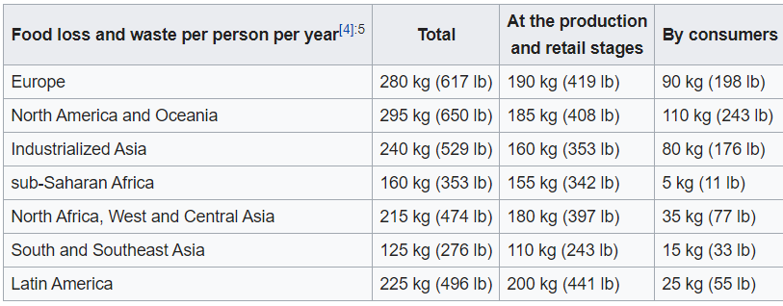

while in developed countries 1,500 calories per day per person are wasted. In the former, more than 40% of losses occur at the postharvest and processing stages, while in the latter, more than 40% of losses occur at the retail and consumer levels. The total food waste by consumers in industrialized countries (222 million tonnes or 218,000,000 long tons or 245,000,000 short tons) is almost equal to the entire food production in [sub-Saharan](https://en.wikipedia.org/wiki/Sub-Saharan) Africa (230 million tonnes or 226,000,000 long tons or 254,000,000 short tons). `1QA

A 2013 report from the British [Institution of Mechanical Engineers](https://en.wikipedia.org/wiki/Institution_of_Mechanical_Engineers) (IME) likewise estimated that 30–50% (or 1.2–2 billion tonnes or 1.18×109–1.97×109 long tons or 1.32×109–2.20×109 short tons ) of all food.

**1.2 MOTIVATION:**

**MOTIVATIONS TO RECYLE THE WASTE FOOD:**

Extant literature on the main motivations that affects Food Waste is limited and fragmented ,since it focuses on single or few variables ,sometimes assuming behavioural and other times socio-demographic perspectives.

Vermier and Verbeke found that everyday purchasing and consuming practices are heavily motivated by a variety of influences such as convenience habitual behaviour , diet and health concerns, perceived value for money ,lifestyle, and social responsibility as perceived through social norms. Factors that influences food behaviours includes social norms ,attitudes ,cultural upbringing, experience ,knowledge , and understanding the food.

A lack of knowledge appears to be one of the drivers in food waste behaviour , in the European union alone, only one-third of the consumers had the ability to comprehend the meaning of the “Best before” date.

However, avoidable food waste also comes from the following identiﬁed behavioural antecedents: excessive purchase, over preparation, and inappropriate conservation. Marketing and sales strategies that are promoted by food companies have a direct and signiﬁcantly negative effect on consumer behaviour , pushing them to develop actions of excessive purchase. Offers, promotions, and the layout of goods in supermarkets can strongly inﬂuence food waste generations; thus, interventions or initiatives that are solely directed at consumers cannot be effective in reducing food waste. This further suggests that food waste occurs at the consumer level and that retailers are key in preventing the generation of food waste.

As for over preparation, the irrational growth of food portions is documented in the literature as contributing heavily to household food waste volumes [33,34]. One way of counteracting it is to consume the household leftovers, which is necessary to help save money and reduce food waste [20]. This is often a cause of waste, since the leftovers are sometimes forgotten or not re-used within a short time [33,35]. Younger people may struggle with this as compared to older people, as older people are more skilled and experienced to use leftovers and foods that are approaching their use-by date safely [17,36]. Moreover, older people are more ethically considerate towards wasting food, as their negative perception of wasting food stems from experiencing food insecurity during World War II [35]. Also, inappropriate conservation is a relevant factor that affects motivations to waste food, since, as found by Farr-Wharton et al. [33], most consumers fail in storing food, as they tend to place food products according to a random and non-systematic approach, which results in food that expires before being relocated.

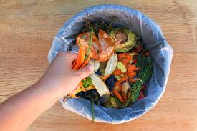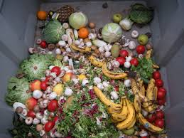

**So, we should not waste the food. And should use it for recycle.**

**1.3 PROBLEM DEFINITION AND OBJECTIVES:**

**PROBLEM STATEMENT:**

* **INCREMENT OF WASTE FOOD IN OUR COLLEGE DAY-BY-DAY.**
* **INCREMENT OF BUDGET OF BUYING VEGGIES AND OTHER GROSSERY.**
* **GUILT OR AWARENESS IS NOT YET CREATED REGARDING FOOD WASTAGE.**
* **TILL THIS DATE THERE IS NO USE OF THIS WASTE FOOD.**

**OBJECTIVES:**

**Food** industry generates enormous amounts of **waste** water and consumes huge quantity of water. It is desired to decrease costs of water, its treatment and plant operation. Reuse of nutrients and organic matter is a great opportunity to achieve these **goals**.

Common causes of food waste in restaurants include overbuying, overproduction, and spoilage. Overbuying is often a result of inadequate forecasting of consumer demand and the large quantities of food that restaurants typically need to purchase at one time.

The **main objectives of waste management** are: for the protection of environment through effective **waste management** techniques. to protect health, well being and environment. to prevent pollution.

The **reduction** of **waste** from sources and the reuse of **waste** through recycling. The **objective** is to decrease the amount of hazardous **waste** bound for energy recovery, treatment, and disposal facilities.

So, we have decided to use the waste food of our college for agricultural purpose so that the money which we are spending for food could be saved a lot. So, the budget we spent on the food can be reduced and we can use this for the other aspects in our college.

**1.4** **PROJECT SCOPE & LIMITATIONS:**

Through making innovative use of deformed fruits and vegetables, connecting with small farms for their extra produce and re-utilizing it, or volunteering with organizations that clean produce from post-harvest, there are many ways that farms can help prevent food waste.

So, if we use the waste food in our college for agricultural purpose then we can reduce the wastage of food and reuse the waste food.

So, we can see in this figure ,the cultivation of vegetables.

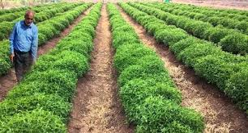

**LIMITATIONS:**

* For using this waste food, it takes some time.
* When food is disposed in a landfill it rots and become a significant source of methane.
* It needs lot of investment.
* It needs equipment’s during this process.
  1. METHODOLOGIES OF PROBLEM SOLVING:

1.Subsistence Farming

Characterized by farmers having small and scattered land areas, most farmers practicing this method are poor who never use:

* Fertilizer
* High-yield seed varieties

They produce for local consumption. In this method, work is done manually following traditional processes.

### **Plantation Agriculture**

Introduced by the British in the 19th century, this method:

* Involves planting a single crop variety over huge tracts of land.
* Requires lots of capital to run.

Also, it’s dependent on:

* Agricultural experts
* Sophisticated farm machinery
* Irrigation
* Fertilizers
* Good transport facilities

### **Crop Rotation**

Here, crops are grown one variety at a time on a land area, usually done to maintain land fertility. Switching crop types on a piece of land takes time and may vary depending on:

* Crop type;
* Duration it takes for a crop to exhaust the land’s fertility.

Cereals are often rotated with legumes which help in nitrogen fixation.

### **Bio-dynamic Agriculture**

Developed in 1924 by Rudolf Steiner, this method considers farms as organisms. In this method, fertility is maintained through planting cover crops or farm animal manure. For a farm to be certified bio-dynamic, it must first be organically certified.

In this agricultural system, farmers follow these measures and rhythms, among other farm customs:

* Homeopathic measures for treating compost plants and soil.
* Natural rhythms to determine planting seasons.

### **Integrated Pest Management**

Also known as IPM, this farming method is based on strategies for pest management and relies on:

* Pest observation
* Pest prevention

IPM makes use of biological controls to get rid of pests. For example, ladybugs are used to devour aphids in farms. Also, this method helps farmers keep track of their land, making it easier to notice arising problems.

### **No-Till Agriculture**

As the name suggests, farmers never have to break the soil and seeds are simply planted on soils. Also, weeds are controlled by spraying herbicides. Another method to control weeds was developed at the Rodale Institute in Pennsylvania, USA where a roller crimper does these:

* Rolls over weeds;
* Leaving the land ready for planting.

These are just some farming methods you should know. Other farming methods include: Organic farming, Vertical farming, multi-crop farming, Green house farming and Playhouse farming. All farming methods are dependent on land size, soil type and other factors.

**2.LITERATURE SURVEY**

Age is a factor that affects food waste, with young people wasting more than older people [9,24]. Food waste falls greatly as age increases; in World, 38% of 18–24 year olds wasted more than $30(AUD) on food over two weeks, in comparison to 7% of 70-year-olds and up . Similarly, in the world, people over the age of 65 wasted signiﬁcantly less food when compared to the rest of the population [9]. However, the claims that all youths and young adults waste food would be fallacious, and it would be wrong to assume that all members of this age group are to be held accountable. study explored food waste behaviours in our youths. food selection highly adhere to the Mediterranean Diet, which is a dietary pattern that is recognized as environmentally-sustainable and entails a high consumption of perishable products (e.g., ﬁsh, fruits, and vegetables). The key factor in such a diet

Sustainability 2019, 11, 1110 3 of 23 is that purchases must be planned correctly, stored, or immediately consumed to avoid generating waste. Upon investigations made students, it was revealed that 59% of youth households wasted 15% or less of edible food, while 63% of various countries youths declared to waste 15% or less of the food that they purchase per week. Only1.7% of youths declared that they wasted more than 30%of food.

2% of youths declared they waste more than 30% of their food. Moreover, there is the indication that more Italian youths are aware of food waste, and that they are more likely to reduce food waste [26], suggesting that food waste is more consciously prevented as compared to other countries, and that awareness is key. In fact, it is regarded that a greater awareness of the consequences of food waste increases the likelihood that youths exhibit behaviour that leads to a reduction in food waste (i.e., make a shopping list) [26]. However, the diet style and awareness may not be the only key factors in reducing food waste.

**SOFTWARE REQUIREMENTS SPECIFICATION**

* 1. **ASSUMPTIONS AND DEPENDENCIES**

Our assumptions behind this outlasting project in the field of software is to briefly make gestures of this wasting food in the minds of humanity for this we are using Google Assistant, how it usually helping us to spread awareness among people.

Not only us but around India if we look 1.6 billion tonnes of food is wasted globally [every year](https://www.bcg.com/en-us/publications/2018/tackling-1.6-billion-ton-food-loss-and-waste-crisis.aspx), a number so big it’s impossible to get your head around—so I’ll try to put it in other terms: 1.6 billion tonnes is the same weight as 4,384 Empire State Buildings.4,384 Empire State Buildings is a lot of wasted food, and that food has an enormous environmental impact. In fact, if food waste was a nation, it would rank as the third highest national emitter of greenhouse gases after the US and China.

The land used to grow food that is subsequently wasted makes up an area 58 times the size of the UK (or almost 3 times the size of the Amazon Rainforest). What’s more, according to the UN, if global food waste was reduced by just 25%, there would be enough food to feed all malnourished people in the world.

Luckily, food waste is most definitely a solvable problem if consumers, businesses, farmers, and governments come together for a sustained effort. One big part of the solution, however, is emerging technology. Many amazing tech companies have come up with creative ways to solve the food waste crisis. I’ve put together here my personal favourites. Here is how you can go through how it is getting seduced [***https://youtu.be/1zxpbOoWoY4***](https://youtu.be/1zxpbOoWoY4)If we take of dependencies there is no such entity we are depending on but there is need to grow guilt behind humanity not only they are wasting but also to suggest other people to do so, means to save food.

If we look on the steps to do so:

Here is how it go so:

* First create console for your module to launch the package means in other words it needs a constructor.
* By using simple intends and its statements we will get success in launching the product.
  1. **Functional Requirements**

For this as we are using Google Assistant in which we are set-upping console module, afterwards uploading data for conversation process finally when the data is got uploaded on the required server just one click launch to web host our requirements.

* + 1. **SYSTEM FEATURE 1:** Set-upping consolefor data analysis and uploading of the surveyed data so that every people should get aware of what we are doing on the regular basis, this can be like ass follows:

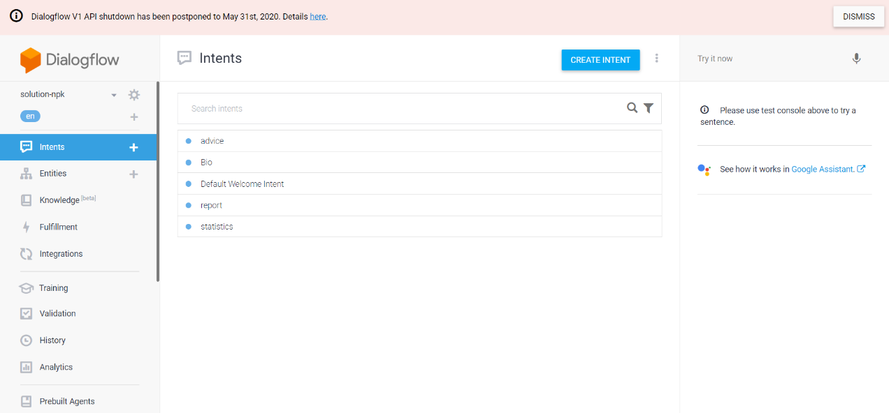

**3.2.2 SYSTEM FEATURE 2:** In phase II we have setting up the conversation in other words dialog flow between the person and the computerised voice to alert on every moment.

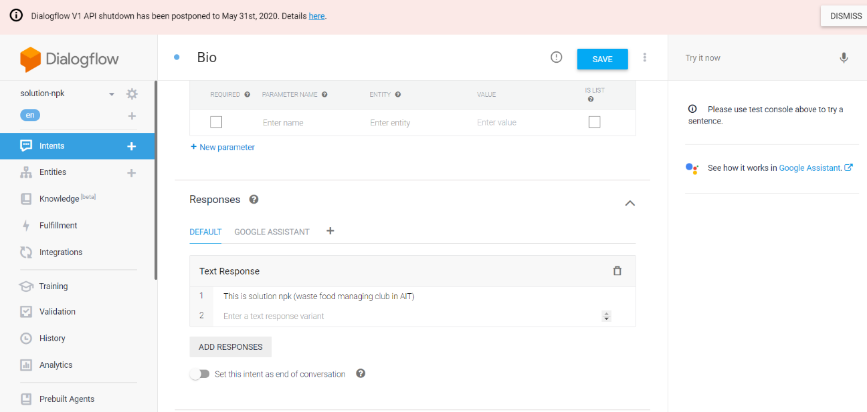

**3.2.3 SYSTEM FEATURE 3:** Finally, in this phase we have to release all data for production, after production it is available for all to access it.

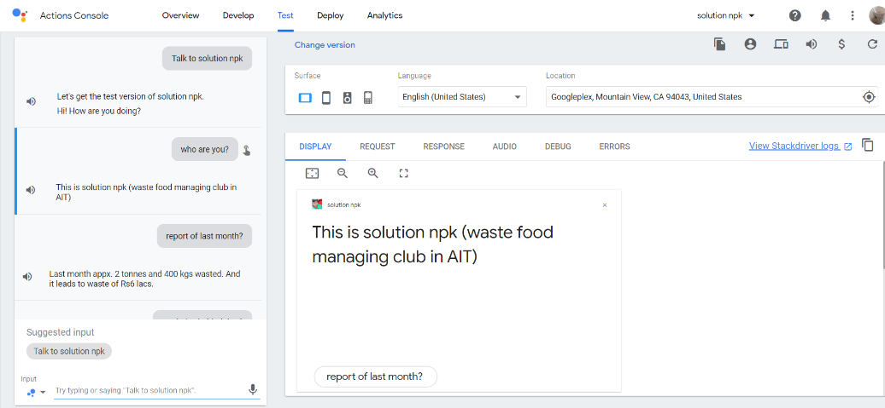

* 1. **EXTERNAL FEATURE REQUIREMENTS:**

In the front end we are using HTML, CSS for the basic design of the page in the prospect of saving the food from being getting wasted. In that we are deciding to create suggestion box for the comments and even complaints too, with the help of these comments and complaints we will try to improve this issue by setting up speakers near the trash bin for awakening people not to waste food as it is limited and if it is not kept in controlled then the day must come when we need to suffer what we do so.

* + 1. **USER INTERFACE:**

Under user interface specially for front end purpose we are introducing HTML page which is specially for managing complains not only complains but also the suggestions too for which we are to eager to introduce such a front end into reality basically for those who waste food on the regular basis. Here is how we did

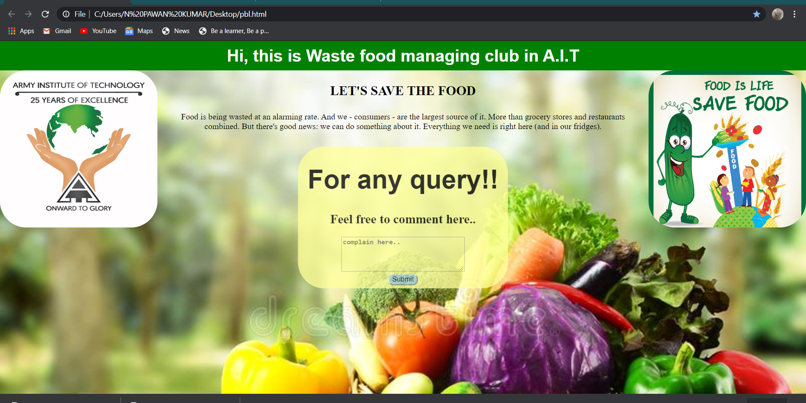

* As we can see above, is a pic how we cope up with the web source for specially to take the opinion of the mankind towards this problem.
  + 1. **HARDWARE USED:**

In hardware we are using digestors for composting the waste food Methane or biogas is a colourless, odourless, flammable gas and the main constituent, 85% to 90%, of the piped natural gas that we use in our homes in the UK, Europe and the USA.

Methane can be made using simple apparatus and a process known as anaerobic digestion. Anaerobic digestion is one of the most common biological procedures in nature, as the name implies, it means to carry or breakdown in the absence of air. Once you know the principles of this process it is possible to make biogas in small or large quantities from a variety of waste materials. The book describes making an anaerobic digester using an oil drum and a rubber inner tube as the gas storage vessel as well as a larger continuous digester. The book also contains diagrams, list of materials and websites for further reading.The gas produced can be used for cooking and heating and even for running a gas engine.

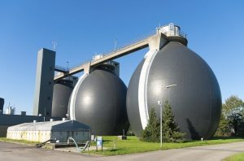

Secondly, the use of composting machines for composting the waste food

A composting machine is a contrivance which facilitates composting. Composting is essentially a biological activity wherein micro organisms break down complex organic substances to simpler ones thereby recycling them for use by plants and other organisms in the soil. For composting to happen moisture, temperature and turning over the material are very important. A device which does this ie; provides these things continuously can accelerate the composting process. Once the composting process starts with the provision of the required materials and factors, it goes on at a rate which depends on the limiting factor. If the influencing factors like temperature and moisture are made available readily, compost forms faster, say in about a month or so. If the factors are not favourable. it could take six months or more. The ideal temperature for composting is about 40 degrees C +/- 5 degrees C. Moisture must be sufficient to keep the medium wet. Water logging can deter the process and so also drying up.

For good quality compost it is essential to use organic matter of plant origin as well as of animal origin. Using only one of the two could result in the compost being inferior. For superior quality compost, it is better to use a wide variety of materials for composting. More the better. Plant matter includes vegetable waste, kitchen waste, husks of grains, all chaff from agricultural produce processing plants, mushroom spent, sugar factory wastes, organic component of solid waste segregation units and other useless agricultural wastes which are otherwise only used for burning. Animal products include abattoir wastes and washings, dungs of all animals, sludge from sewage treatment plants, slurry from gobar gas plants, etc. Virtually all organic material can be used unless it has toxic industrial wastes containing heavy metals or poisons. They have to be mixed well, moistened and allowed to digest with at least two turning overs - one after 10 days and another after another 20 days. Heat is a by-product, dissipating which helps the process.

Here is how it usually looks,

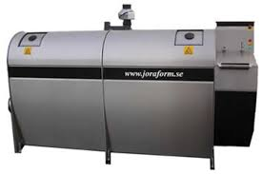

* + 1. **SOFTWARE REQUIREMENTS:**

In the software requirements we used HTML,CSS and Google Assistant for our project Basically HTML and CSS for creating and designing exotic and amazing front end which will be available to all users after it will get web hosted Actions on Google is a developer platform that lets you create software to extend the functionality of the [Google Assistant](https://assistant.google.com/), Google's virtual personal assistant, across more than 1 billion devices, including smart speakers, phones, cars, TVs, headphones, and more. Users engage Google Assistant in conversation to get things done, like buying groceries or booking a ride (for a complete list of what's possible now, see the [Actions directory](https://assistant.google.com/explore/).) As a developer, you can use Actions on Google to easily create and manage delightful and effective conversational experiences between users and your own 3rd-party service.

This code lab module is part of a multi-module tutorial. Each module can be taken standalone or in a learning sequence with other modules. In each module, you'll be provided with end-to-end instructions on how to build an Action from given software requirements. We'll also teach the necessary concepts and best practices for implementing Actions that give users high-quality conversational experiences.

This code lab covers intermediate level concepts for developing with Actions on Google. We strongly recommend that you familiarize yourself with the topics covered in [Build Actions for the Google Assistant (Level 1)](https://codelabs.developers.google.com/codelabs/actions-1/index.html) before starting this code lab.

* + 1. **COMMUNICATION REQUIREMENTS:**

 The process of communication requirement analysis in to overall communications planning. It will also recommend components to consider including in a communications plan and suggest ways to perform communication requirements analysis.

Data shows that a project manager spends roughly 90% of his time communicating. If this is true, in order to be successful and effective in their job, a project manager will want to be clear on what the communication requirements are for the project he is leading.

Of course, the project manager isn't the only one with responsibility for effective communications. A project team is comprised of team members that have come together from previous experiences where they all used different communication techniques and had responsibilities for different communications. It makes sense to invest time early in the project to get a new project team on the same song sheet about how communications should be handled throughout the life of a new project.

Can you think of a scenario where having a documented communications plan would be helpful? Imagine a team member who is new to the project wondering *Who needs to know about the new requirement the customer just added?* Or *Who is authorized to make the final decision between option 1 and option 2 of this design revision?* Quickly glancing at the project communication plan is a more productive way to get these answers than taking time to make several phone calls or interrupt co-workers in search of the answer.

Analysing communication requirements is a part of overall project communications planning. A communications plan is typically one of a project's first deliverables. It involves collecting and summarizing important information about how communications will be managed throughout the life of the project. Once assembled, the project's communication plan should be reviewed and approved by the project manager and project team.

* 1. **SYSTEM REQUIREMENTS:**

As a student level, we know that writing good system requirements specification is pivotal to the success of any software project. Working with dozens of different requests from various industries we have accumulated knowledge and created a vision of how ideal SRS documentation should look like. In this article, we share our best practices for creating outstanding SRS documentation which will be both very comprehensive for the developers and protect your project from some of the challenges you and your business may face without having well-outlined system functionality and requirements to the final software.

* + 1. **DATABASE REQUIREMENTS:**

For this we planned to use php as our leading data base mainly to process the data in the form of comments Creating a **project** in **PHP**, is fairly similar to creating the ones in HTML or JavaScript. You write the code and then save it with a . ... To actually run **PHP** scripts, you will have to run it on a server. In developmental phase, you can **use** the local host to run your **projects**.

* + 1. **SOFTWARE REQUIREMENTS:**

In the software requirements we used HTML,CSS and Google Assistant for our project Basically HTML and CSS for creating and designing exotic and amazing front end which will be available to all users after it will get web hosted Actions on Google is a developer platform that lets you create software to extend the functionality of the [Google Assistant](https://assistant.google.com/), Google's virtual personal assistant, across more than 1 billion devices, including smart speakers, phones, cars, TVs, headphones, and more. Users engage Google Assistant in conversation to get things done, like buying groceries or booking a ride (for a complete list of what's possible now, see the [Actions directory](https://assistant.google.com/explore/).) As a developer, you can use Actions on Google to easily create and manage delightful and effective conversational experiences between users and your own 3rd-party service.

This code lab module is part of a multi-module tutorial. Each module can be taken standalone or in a learning sequence with other modules. In each module, you'll be provided with end-to-end instructions on how to build an Action from given software requirements. We'll also teach the necessary concepts and best practices for implementing Actions that give users high-quality conversational experiences.

* + 1. **HARDWARE REQUIREMENTS:**

In Hardware requirements we have during process the gas called, Methane gas can be made using simple apparatus and a process known as anaerobic digestion. Anaerobic digestion is one of the most common biological procedures in nature, as the name implies, it means to carry or breakdown in the absence of air. Once you know the principles of this process it is possible to make biogas in small or large quantities from a variety of waste materials. The book describes making an anaerobic digester using an oil drum and a rubber inner tube as the gas storage vessel as well as a larger continuous digester. The book also contains diagrams, list of materials and websites for further reading. The gas produced can be used for cooking and heating and even for running a gas engine.

**04. SYSTEM DESIGN**

4.1 SYSTEM ARCHITECTURE

Firstly we analyze that how much food is wasted in our collage day to day and we contact all food mess in charges to know the information about wastage of food in our collage and then we analyze this on a bigger by calculating this food wastage in terms of money and we found this problem is not small as much as we are thinking so, because the amount wasted is very huge amount and then worked on that issue on how to minimize this wastage and we come to a solution to awaken the students of our collage by using some technology like digital awareness.

Finally we came to a solution to solve this issue on a digital basis with help of Google assistant and website on which we can work on the complains and comments received from the students, on a research base we found that composter can solve this issue in min. time and slowly we can minimize this problem in our collage. And by solving this problem we also save the budget which is used in buying food vegies and this money can be used in other innovation cells so, there will be no issues for any club related to money.

4.2 MATHEMATICAL MODEL

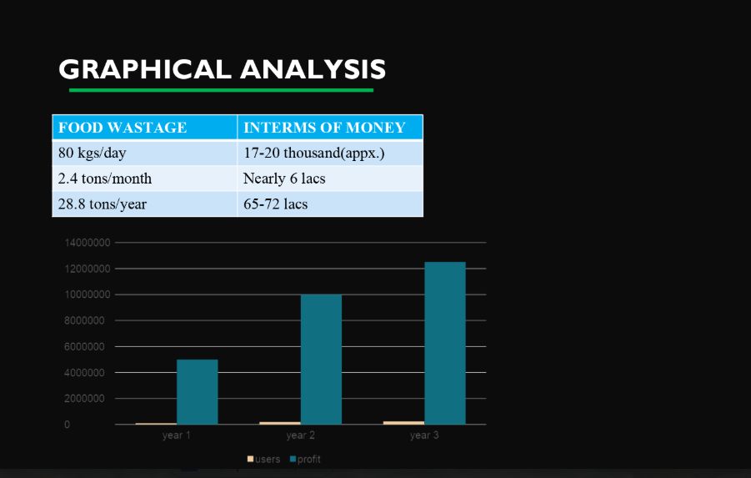

4.3 DATA FLOW DIAGRAMS

* We design this flow diagram on the basis of when AIT food wastage not in use or in use and we give the detail about the consequences and impactness when this food waste is in use or not in use.
* We also give the information about how we solve the problem by converting waste food into manure and by using this technology.
* We also give the information of what is the benefit of solving this problem and producing nutritious diet.
* The below mentioned flow chart is the analyzation all the problems related to this and the benefits too.

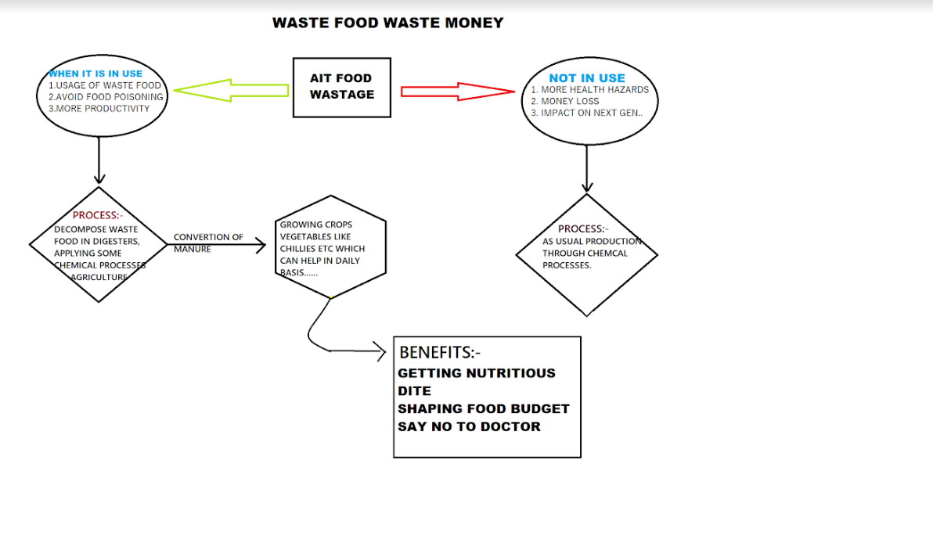

**05. PROJECT PLAN**

5.1 PROJECT ESTIMATE

5.1.1 RECONCILED ESTIMATES

we estimate that the waste food will be minimized by doing some important steps. like awaring the student about that how much food is wastage day by day and that is not good for our environment as well as for our college. Firstly we develop a google assistant to give the information about the daily wastage of the food in our colleget.so the student getting aware about this problem and not waste the food. And slowly slowly we minimized the food wastage in our college and we also save the money which is used in a buying food items and this money can be used in many ways in our college like clubs and innovation cell.

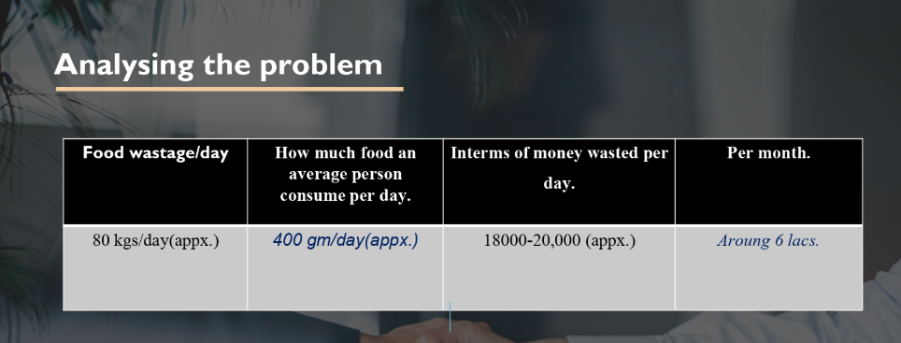

**5.1.2 PROJECT RESOURCES**

1. For collecting the information about wastage of food in our college so we contact to the all food mess in charges to give the information about the daily food wastage.
2. We are planning to convert this waste food into compost or fertilizer which is done only by composter. And the working process of this composter is fast because the food waste in our college is in huge amount.
3. We also learn some technology to develop the website like we work on HTML, CSS node js,and using advanced technology to enhance our website and for google assistant we learn some basic technology .
4. For developing this google assistant application we took help of google actions console, we made intents and conversation and finally we launched it for production.
5. And regarding website we took help of HTML and CSS for developing front end and regarding data processing we took help of java script and PHP.

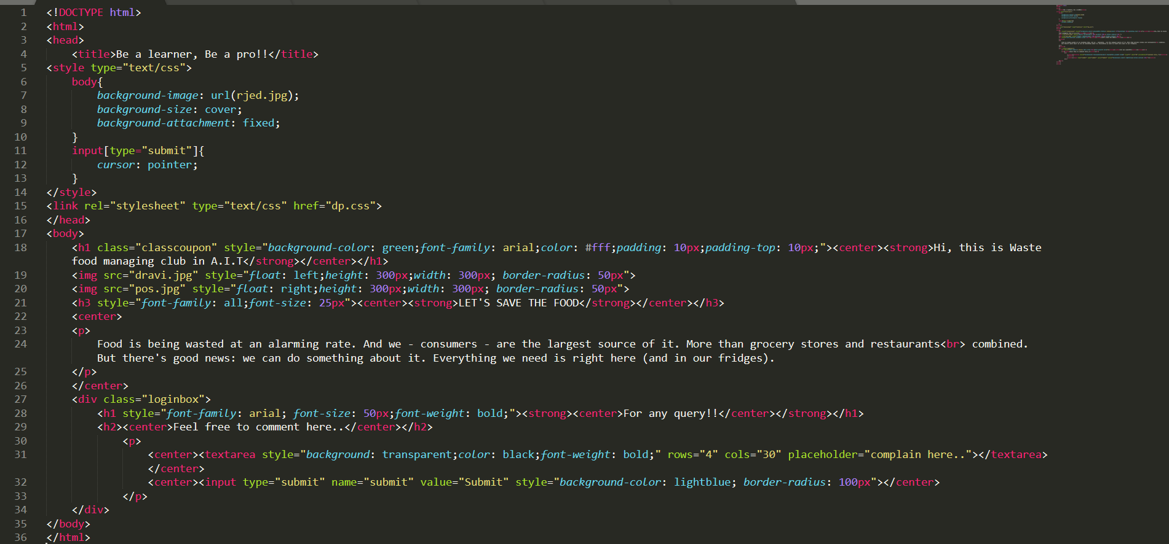

* 1. **PROJECT SCHEDULE**
* We surveyed food messes and collected information related to the, afterwards we sub categorized this problem into sub-problems.
* About 20days we discussed this problem and came to a solution and how to overcome this problem by using digital awareness.
* And about next 15days we developed this solution-npk app by learning through online courses.
* And we took about 30days to develop front end and back end of the website using JavaScript.
* We took about 5-8days we researched on the composting machine and we specially researched for the machine compost food in min. time.
* By developing all this, finally we come with our project among all first year students and got selected for giving the presentation to the director of our collage.
  1. **TEAM ORGANISATION**
     1. **Team Structure**

|  |  |
| --- | --- |
| **Name** | **Assigned Responsibility** |
| Ravindra Singh | Backend work – Full rendering of data on different pages using Express.js , etc.. |
| Reetesh Tomar | Front end work- designed the home page and blogs page using HTML, CSS, Bootstrap, etc.. |
| Rajesh Kumar | Complete database for the website using MongoDB and mysql. Collected information from mess |
| Shubham Choubey | Front end work- designed the voting page and waste management page using graph.js |
| Banti Kumar | Front end work-designed the login page for the users and selected different themes to be used in the website look |

**5.3.2 MANAGEMENT REPORT AND COMMUNICATION**

we give the sub work to our team member in which there are five member in our team and each one is doing their sub work like some individual is working on the website some are working on the survey of the food wastage in our college. some member is working on the research to how to minimize the food wastage in our college and also research about the technologies used in the composter.

**06. PROJECT IMPLIMENTAION**

* **Overview of project modules**

In our project we develop the website and google assistant app for giving the data of waste food in our college .and also give the information about the how much money is wasted daily so that the students can analyses and feel the problem of our college.

we actually covert this food wastage into compost by composter and we also develop the website to connect those NGO who are working on the helping the poor children by giving the food and help those poor children.

**06.PROJECT PLANNING**

**OVERVIEW OF PROJECT AND MODULES**

**variety of instruments to analyze soil samples including:**

* atomic absorption spectrophotometers;
* Inductively Coupled Plasma Spectrometers (ICPs);
* Lachat Flow Injection Analyzer;
* colorimeters; and.
* general laboratory equipment

software used in testing of soil

[**Ag Manager**](https://www.environmental-expert.com/software/brand-ag-manager)**- Resin**[**Soil Testing**](https://www.environmental-expert.com/software/keyword-soil-testing-1130)**Software**

UNIBEST Ag Manager™ Resin Soil Testing is proving to be the leading indicator to plant nutrition through critical soil release measurements modeled against crop nutrient requirements in Lbs/Ac/Day. This PREDICTIVE measurement focuses not on the soils total nutrient level (lbs./ac), but that soils ability to release those nutrients at rates that match Plant Uptake Demands (Lbs/Ac/Day). Yield and quality is being left in the field by not leveraging this critical measurement that is now commercially available after years of University Research.  Start building soils to release nutrients that match specific crop demands throughout the growing season.

# [AgStudio MAP](https://www.environmental-expert.com/software/brand-agstudio-map) - [Soil Sampling](https://www.environmental-expert.com/software/keyword-soil-sampling-969) and [Mapping Software](https://www.environmental-expert.com/software/keyword-mapping-software-79051)

Whether you need to soil sample one field or one hundred, AgStudio MAP integrates seamlessly with [AgStudio](http://www.mapshots.com/products/agstudio/) to efficiently perform wireless exchange of sampling work orders between your desktop and your iPad. Use AgStudio MAP to bring needed efficiencies to the [soil test automation process.](http://www.mapshots.com/agricultural-industry-solutions/soil-test-automation/) AgStudio MAP provides the capabilities to draw boundaries by hand or via GPS, lay grids, and perform the soil sampling and mapping tasks based on sampling work orders generated by AgStudio.

* 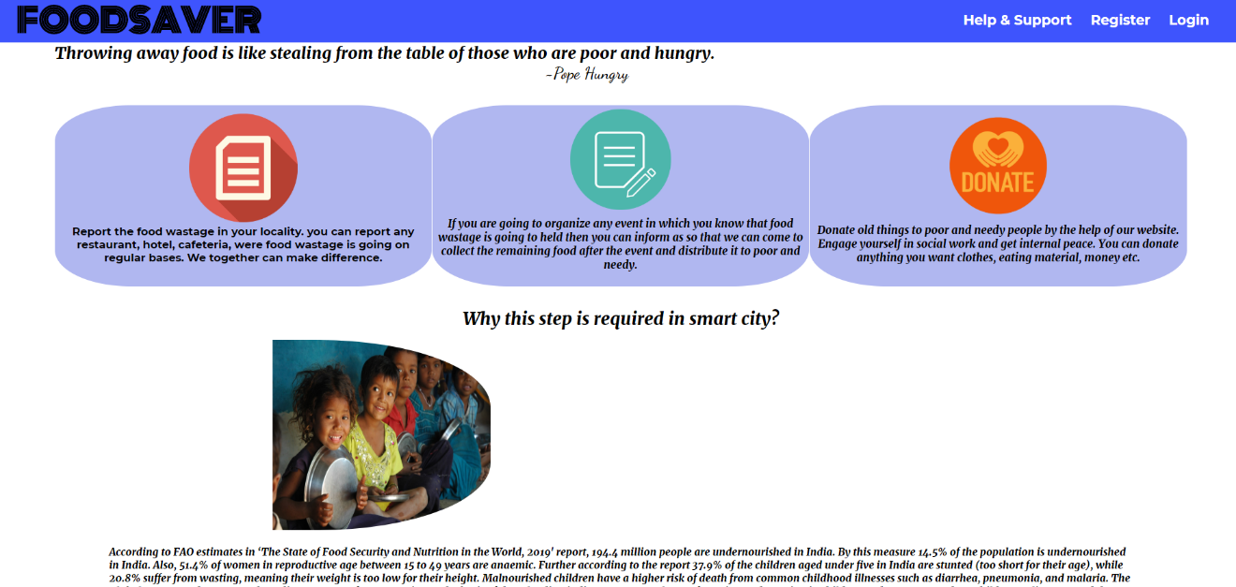**Tools and technologies**



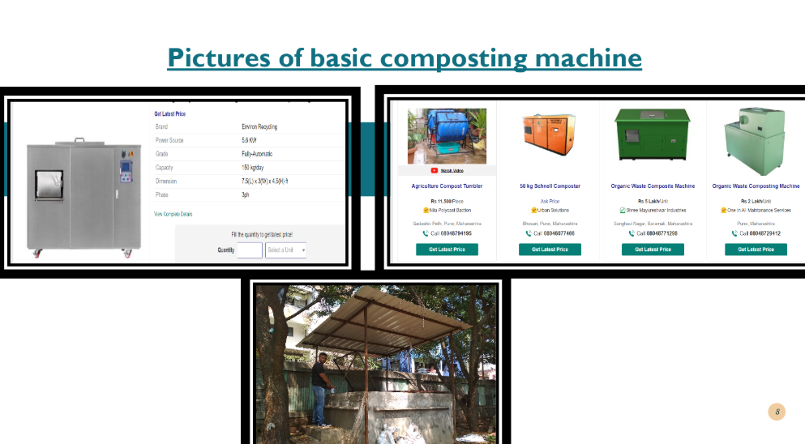

**6.3 ALGORITHM DETAILS**

the step by step process in our project is that firstly we go through know how much amount of food is waste then we convert this food into composite or fertilizer and then we used it in the growing a crops in our college.

then one member of our team feed the details in the google assistant app that how much food is wastage in daily with their money so that the student got realizing about the problem. and due to the digital awareness the students of our college not waste that much level of wood.

and we slowly minimized the food wastage in our college.

**07. SOFTWARE TESTING**

Software is to briefly make gestures of this wasting food in the minds of humanity for this we are using Google Assistant, how it usually helping us to spread awareness among people.

Not only us but around India if we look 1.6 billion tones of food is wasted globally [every year](https://www.bcg.com/en-us/publications/2018/tackling-1.6-billion-ton-food-loss-and-waste-crisis.aspx), a number so big it’s impossible to get your head around—so I’ll try to put it in other terms: 1.6 billion tones is the same weight as 4,384 Empire State Buildings.4,384 Empire State Buildings is a lot of wasted food, and that food has an enormous environmental impact. In fact, if food waste was a nation, it would rank as the third highest national emitter of greenhouse gases after the US and China.

**7.1 TYPE OF TESTING**

In this software testing we are nothing but launching our resource to people just not to earn but awaken them with the help of Google Assistant, and also developing front end using HTML,CSS for the people to put complains before so, that NGO look into what’s going on



**7.2 TEST CASES AND RESULTS**

We got better test results when we applied same to launch in our collage we got best project plan thinking award from our respected sir, and we are launching the same to the humanity to get in touch with it, work with it, and learn and understand with it.



**“This is our software prototype”** of launching among people for making them alert in the every point of issue they deal with food.

* **FOR THE FRONT END PURPOSE**

# 08.RESULTS

The best thing of our project is it is based on primary necessity of life, that is food. We tried to cover every possible use of food. This project is not limited only at college, but all around the city, state and country.

**Outcomes** The outcomes of project are mention here properly.

**VOLUNTEERS WITH LOCAL COMMUNITY OF FOOD DISTRIBUTOR** In every city there

are organizations like NGO, NSS, etc. We have to contact them to distribute food which is in access amount and not fresh. This will be a great step towards humanity.

**AWARENESS** There is concept of digital work. In every community people will be connected through phone. Example In college every student will get notifications of today wasted food and it's cost and how many people can save their life if they get that food. This will motivate them for understanding the value of food.

**SUPPORT BUSSINESS** It is main motive of our project. Here we are going to make a machine which will convert waste food into bio gas and compost. Usually, compost plants are being used, but issue is that there needed a large space, it takes more than one month to convert into compost. There is hygienic issue because it is made on land and obviously it can't be used in our college being comparative small. Actually, here will be a machine like box type which will convert into compost and bio gas in 24 hour.

**09. CONCLUSIONS**

* 1. **Conclusions**

All in all, this paperwork aim is to show the importance of recycling food waste and helping the environment by building a machine that convert food waste into compost. The machine is completely manufactured in India. This food waste recycle machine is to be built and used at every place safely.

The design methodology and the engineering solutions that will be used in this project were explained in the engineer design process. Followed by the identifying the customer, knowing there needs and taking their feedbacks which are considered important since our purpose is to satisfy the customer needs. Further more, a quality function deployment was used to translate customer need into design specification. In addition, theexternal and internal constraints and the design standards were identified. Moreover, the alternative, evolution and the machines final design all were discussed briefly and shown in detail in this project.

Since the world is seeking sustainability our machine aims to lessen the food waste that is through into the landfills, which pollute the environment by recycling the food waste and turning it, in less than twenty four hours, to compost that can be used in fertilizing the soil to plant healthy and organize food and contributing in creating a safe and sustainable world.

* 1. **Future Work**

User interface require more improvement and we are planning to combine both of the app in one single app also we are planning to develop an app which will help in creating awareness among people. We also planning to download and integrate an offline google map of whole India into this app. By this it will help us to spread by taking the data into the medium to create humanity.

* 1. **Applications**

This app can have application of collecting data of state wise of how much food is getting wasted every where in the offense that will definitely help to calculate the fund from that waste food, which will extremely help illiterate and literate to in understanding the strategy of what and why? We are doing not for the sake but the 40% who are still striving instead of much development and social management.

In this whole we are taking help of social, media into account because it is the main point to trigger the problems into reality.

**“BECAUSE ONLY ONE PEOPLE CAN HELP THE OTHER”**

**References**

1. Python and Django framework
2. HTML, CSS, Bootstrap for front end development.
3. Wikipedia for planning architecture.
4. YouTube for video tutorial